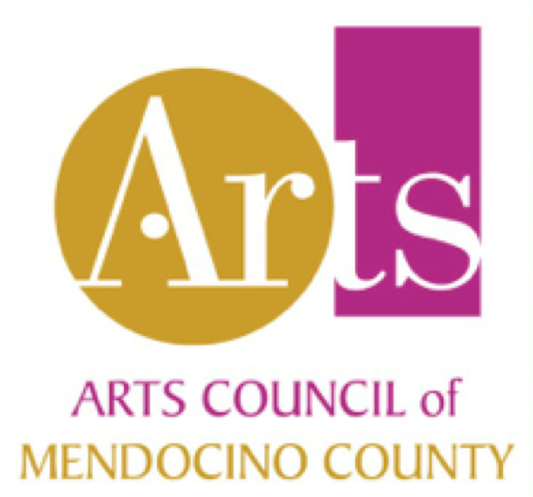
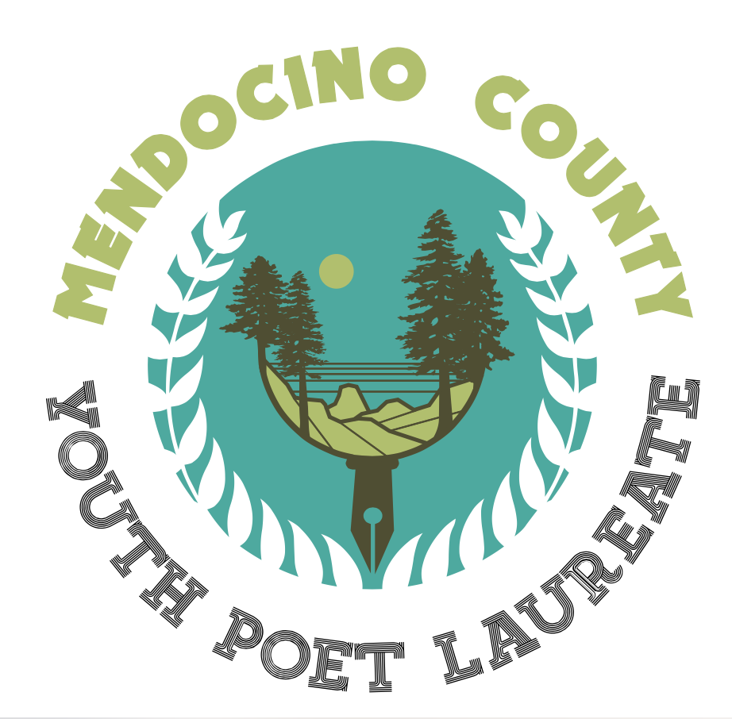
PLEASE SUBMIT YOUR APPLICATION VIA EMAIL: blake@arenatechcenter.org
If you have no means to apply online, you may mail-in this form; see the address at the bottom of the page.

Applications must be received by Wednesday, November 1, 2023
Questions? Email Blake More blake@bmoreyou.net
or call (415-283-8204)
Eligibility: Applicants must
- be a Mendocino county resident
- be between the ages of 13 and 19 as of September, 2023
- be available to serve as Laureate for the program year, December 2023 – December 2024:
→ be living locally through the program year
→ not be enrolled in college full-time during the program year
Poems will be judged based on Content, Craft, and Voice. If you are entered into the final round, applications will be additionally judged on Leadership and Performance.

For more information, visit: https://www.bmoreyou.net/youth-poet-laureate-2023-24/

APPLICATION
 |  | Part A. Your Information (required)
Name: | Pronouns: Birthdate:
 | Last First MI |  | Month/ Day/ Year
Address:
 | Street Address
 | CA
 | City | State | ZIP Code
Phone: | ( ) | E-mail:
School: | Grade:
How did you hear about the Mendocino County Youth Poet Laureate program?
Are you planning to be in Mendocino county for the full Poet Laureate program year (Dec 2023-Dec 2024)? |  |  |  | YES | NO
Artist Statement/Bio: Introduce yourself. Tell us who you are and what poetry means to you. (250 words maximum. Use a separate document/piece of paper if needed) Required. Note: This may be used as your bio if you advance to the final round.

Page 1 of 2 pages
Part B. Awards and Service
List any awards or honors you have received (including anywhere your work has been published). List any community service or activism you have done (you may use a separate piece of paper).
Part C. Your Writing (required)
Please attach printed copies of three of your original poems, totaling no more than 10 pages.
Part D. Name of Adult Sponsor (required)
Please provide the name of an Adult Sponsor who you can ask to write you a letter of recommendation IF you advance to the final round. Tip: Choose someone who knows your writing, school performance or community involvement.

Sponsor Name:

Phone Number or Email Address:
Signature & Guardian Information
Name of Parent/Guardian
(Not required if you are 18 on Nov 27, 2023)

Phone Number or Email for Parent/Guardian:

By submitting this application, I agree that the poetry I submitted is my original work and I meet the Youth Poet Laureate eligibility requirements. I understand that if I advance to the final round, my writing may be published as part of the program, but I still retain the full rights to publish or perform my work anywhere else I choose.
Signature: | Date:

THANK YOU!

Page 2 of 2 pages

